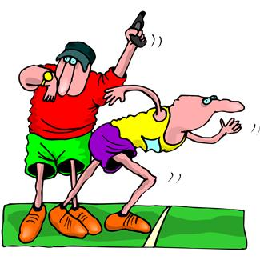
Story Writing Organizer
Beginning: Entertaining beginning/ Introduce main characters/ Establish setting/ Let the reader know what is happening

What is happening at the beginning of the story?
Who are the main “stars” or characters in the story?
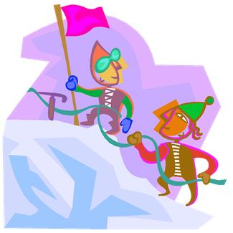
Problem: What is the problem/ difficulty or conflict in the story?
1

Middle: Story Problem/ Rising Action/ Story Scenes

Rising Action: Two things that happen as the character attempts to solve the problem in the story
2

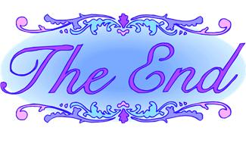
3

Climax: Turning point in story where the problem ends

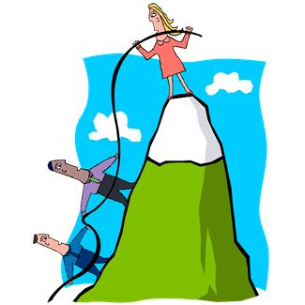
End: What comes right after the climax in the story

